Docker Volumes SOP



Table of Contents

1. Docker Volumes 3
1.1 Description 3
1.2 Architecture Diagram 3
1.3 Lab Steps 4
1.4 Troubleshooting 5
1.5 Supporting References 5

Docker Volumes

Description
Containers are more and more important in any IT environment. Although the most commonly known container management system is Docker, there are other container engines available. In this lab exercise, docker is installed on an EC2 instance and docker volume is added to a container.

Architecture Diagram
The diagram below displays a visual representation of the underlying application architecture:

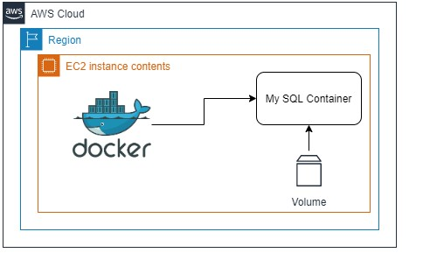

Lab Steps
- Create an EC2 Instance (Ubuntu 20.04). Make sure that the role CCL-EC2-Role is attached to the instance. Only then SSH is possible via Sessions Manager.
- Change the user to Super user or root user.
- Change directory to “~”
- Update the instance with the following command:
sudo apt update && sudo apt upgrade
- Uninstall previous versions of docker (if any):
sudo apt-get remove docker docker-engine docker.io containerd runc
- Install prerequisite packages using the following commands:
sudo apt-get install apt-transport-https ca-certificates curl gnupg-agent software-properties-common
- Add the Docker GPG Key:
curl -fsSL https://download.docker.com/linux/ubuntu/gpg | sudo apt-key add –
- Add the Stable Repository:
sudo add-apt-repository "deb [arch=amd64]
https://download.docker.com/linux/ubuntu $(lsb_release -cs) stable"
- Install Docker:
  - sudo apt-get update
  - sudo apt-get install docker-ce docker-ce-cli containerd.io
- Execute the following command to check if docker is installed correctly:
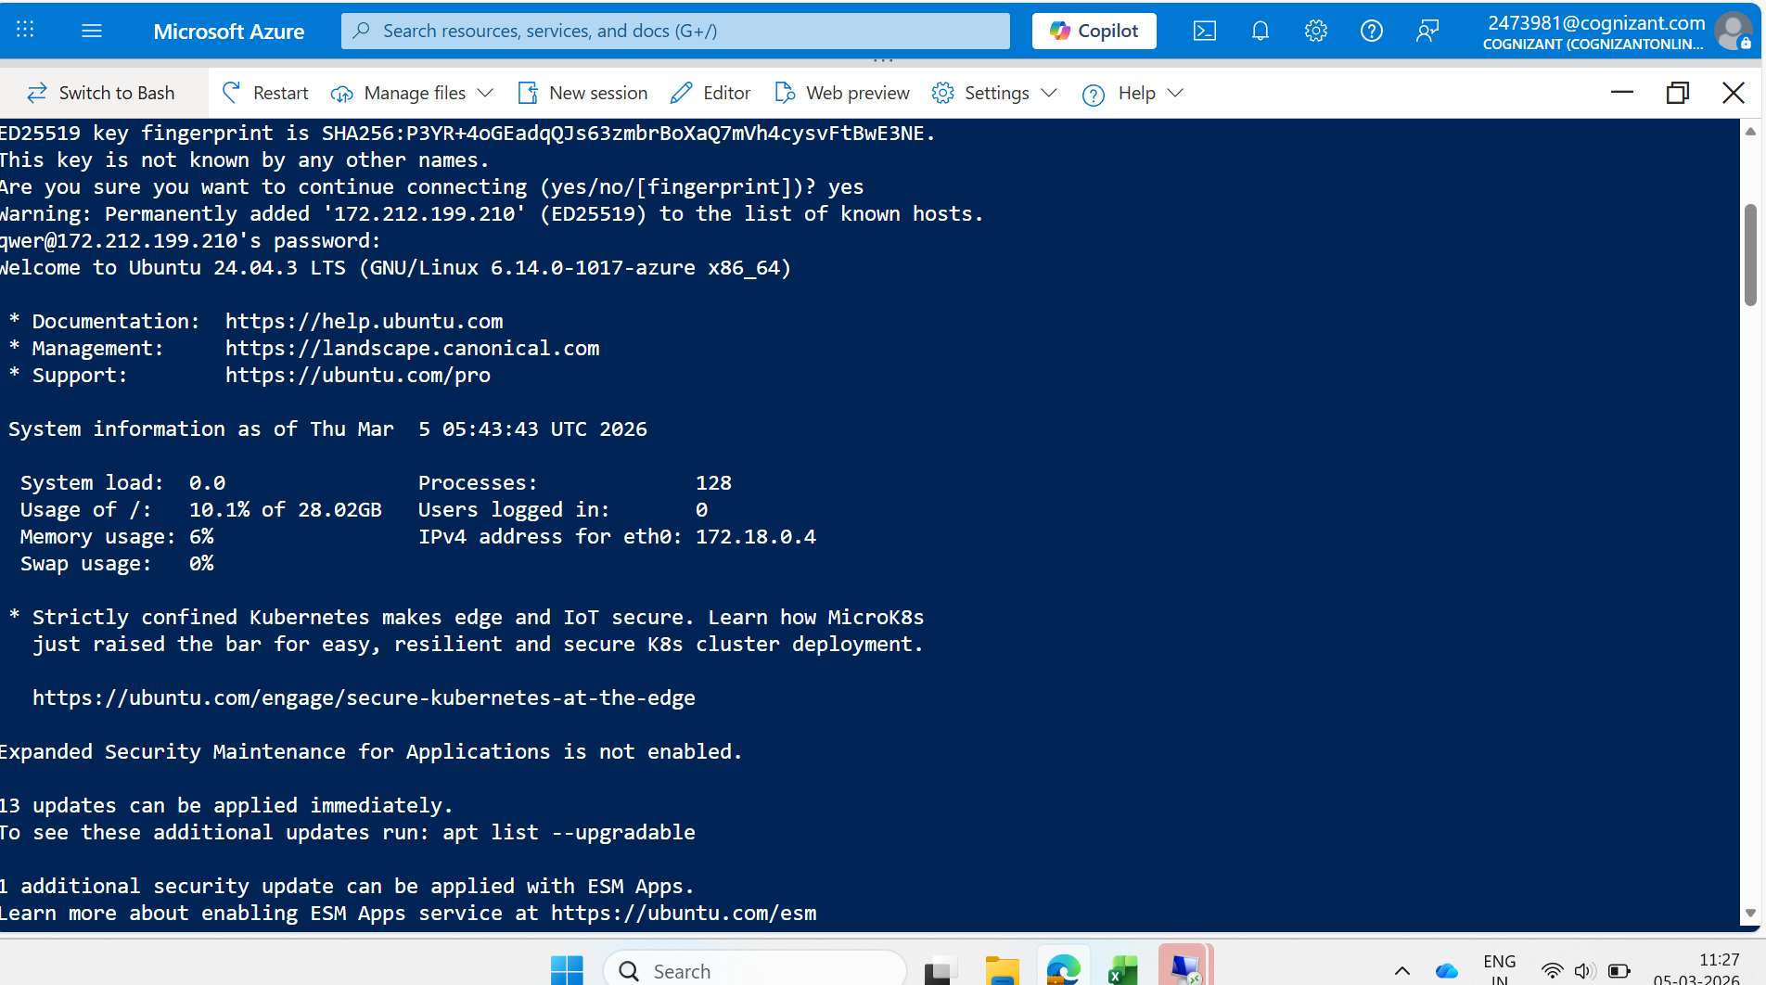
docker version
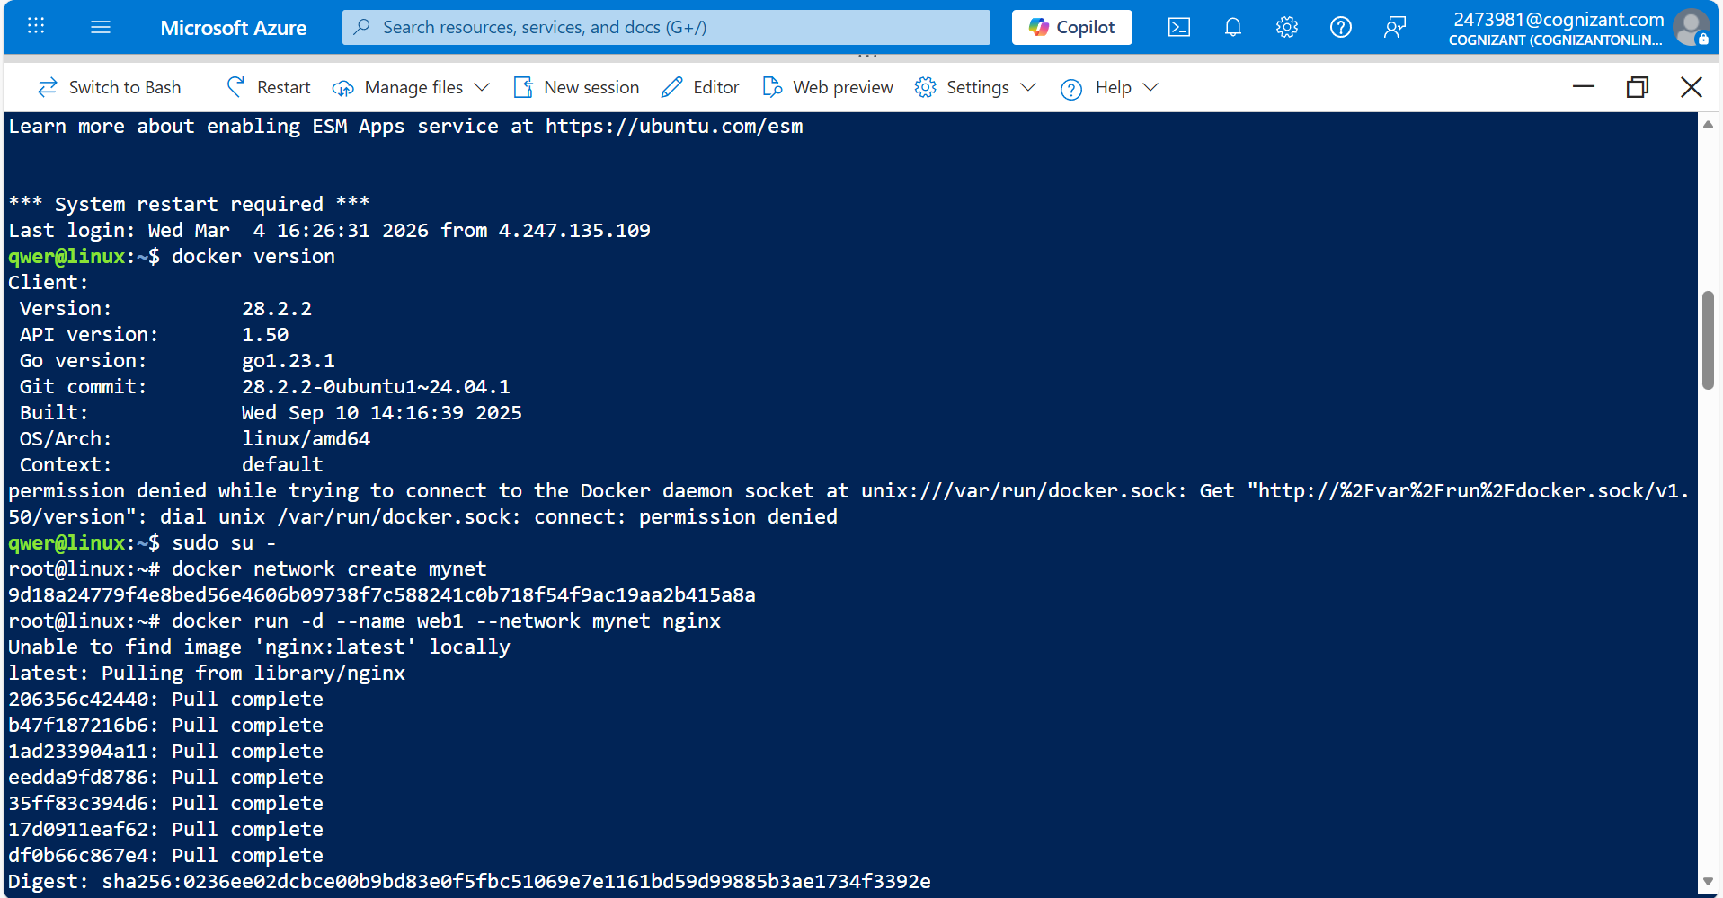
- Create a new volume:

docker volume create mysql_data
- Pull and run a MySQL Image with the created volume:
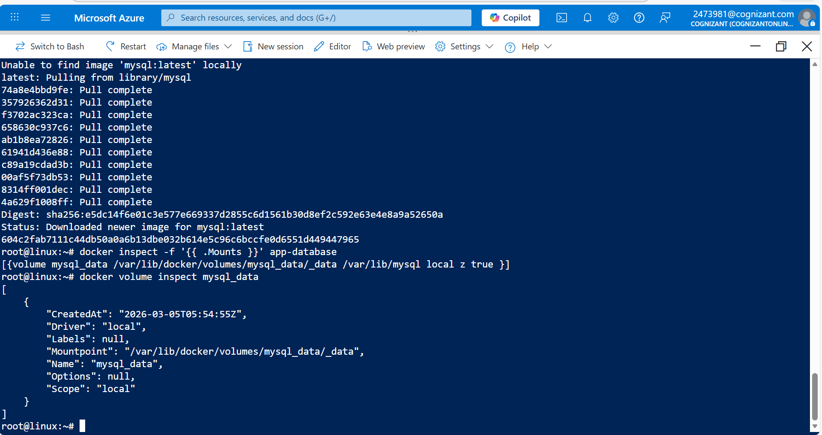
docker container run -d --name app-database --mount type=volume,source=mysql_data,target=/var/lib/mysql -e MYSQL_ROOT_PASSWORD=P4ssW0rd0! mysql:latest
- Check if the volume is attached to the running container:
docker inspect -f '{{ .Mounts }}' <containerid>
- Container ID can be found using the command:
docker ps

Troubleshooting
S. No | Problem | Solution
1 | Not able to SSH | - Make sure that the role CCL-EC2Role is attached to the instance  - Stop and start the instance  - Wait for 6 - 12 minutes and check.
2 | Some commands are not working | - Make sure that the “-“ command is proper. Example: its --list and not – list  - Replace the placeholders (<>) with the specified values
3 | Not able to run Docker | Follow the steps in the link available in the Supporting References Section.

Supporting References
Refer the below link for additional information:

1. https://docs.docker.com/engine/install/ubuntu/

